

# Books Library

# Group Members:

## Sushmita Nandalan – 300923159

## Chanpreet Mudhar – 300932732

Table of Contents

Books Library 1

Group Members: 1

Sushmita Nandalan – 300923159 1

Chanpreet Mudhar – 300932732 1

Detailed description 3

Version History 3

GITHUB SCREENCAPTURE 3

Typography and Color 4

Wireframes 5

Capture Section 5

# Detailed description

A website that shows a books library which has a wide variety of books from various authors and genres. The main page will show a brief description about our library and will include links to the other pages. Also, the main page will have a list of books button that will take user to the list page which will display the list of books. The details of the book will be shown on the page. The book details include the book title, author, genre, rating, format, cost, and other publishing details.

# Version History

(at least 4-5)

V0.1 Site structure and main page

V0.2 Connected to the database and displayed list of books in the list page

V1.0 Full featured release site.

## GITHUB SCREENCAPTURE

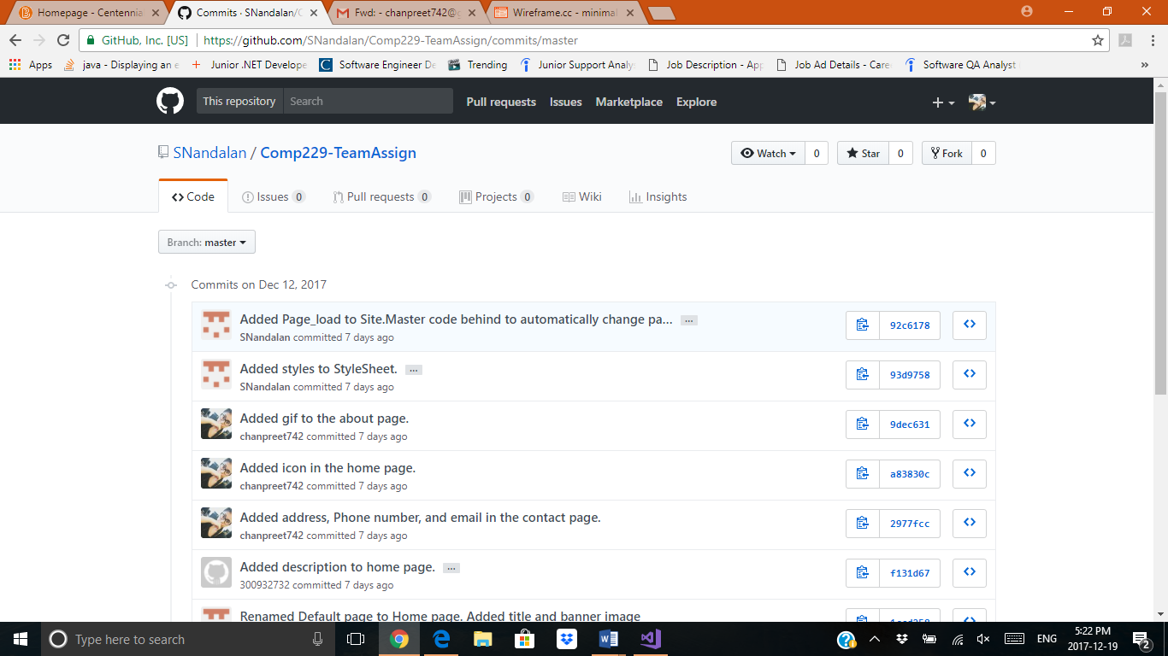

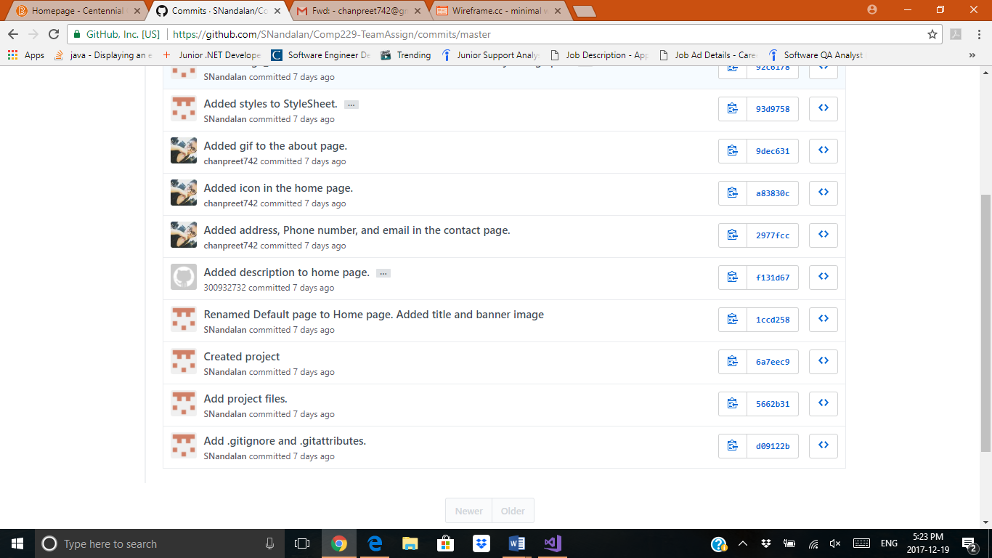

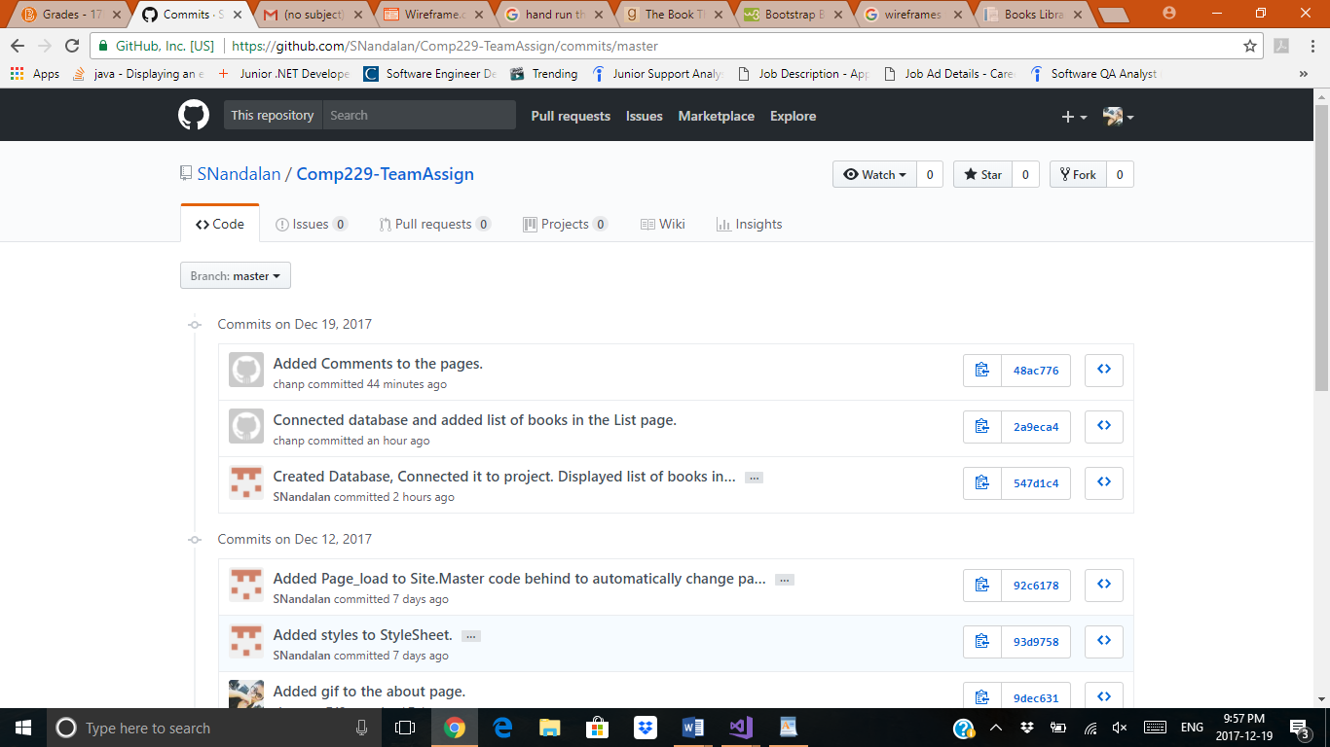

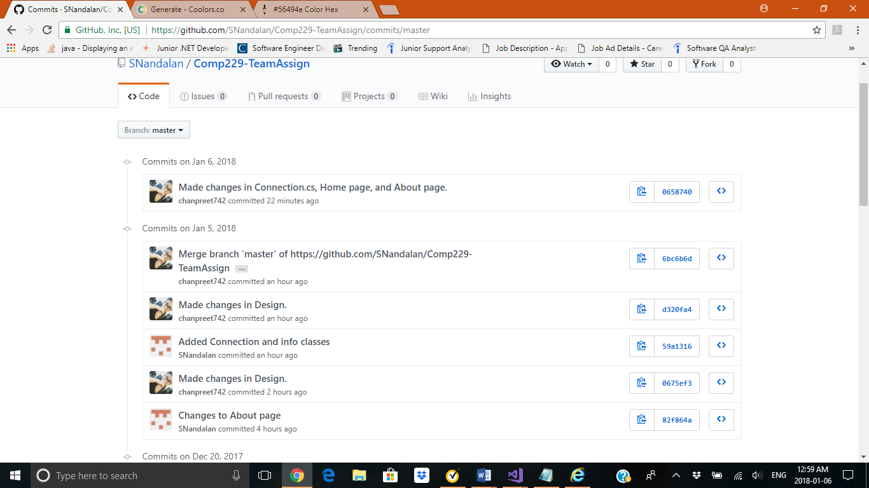

# Typography and Color

All fonts are client defaults

Lucida Sans

|  |  |  |
| --- | --- | --- |
| #0000 | |  | | --- | |  | |
| #56494E | |  | | --- | |  | |
| #D6D7DF | |  | | --- | |  | |

# Wireframes

1. Wireframe for home page:

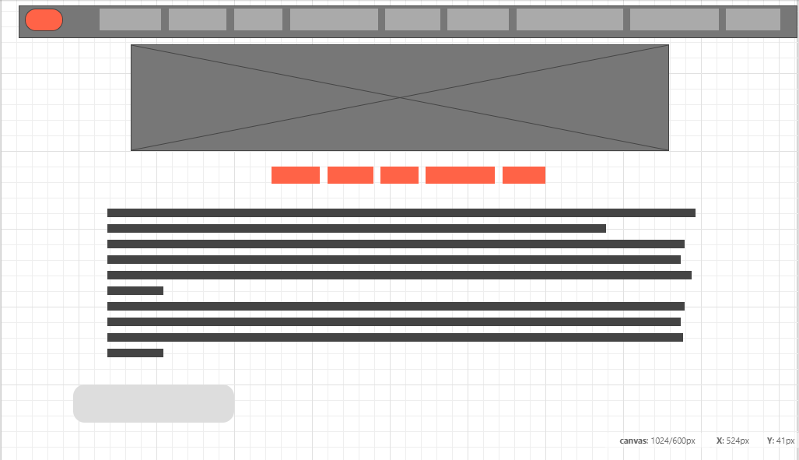

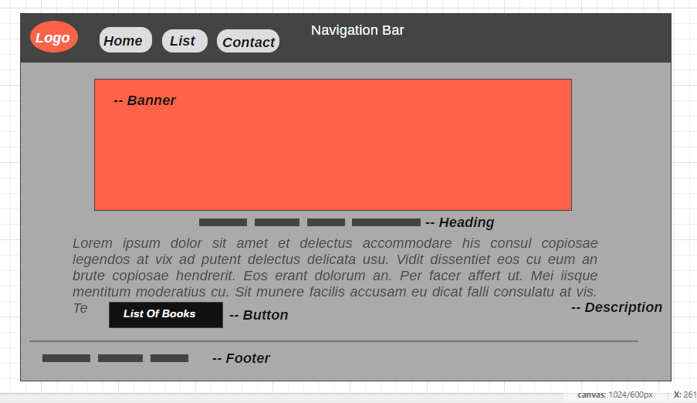

1. Wireframe for List Page:

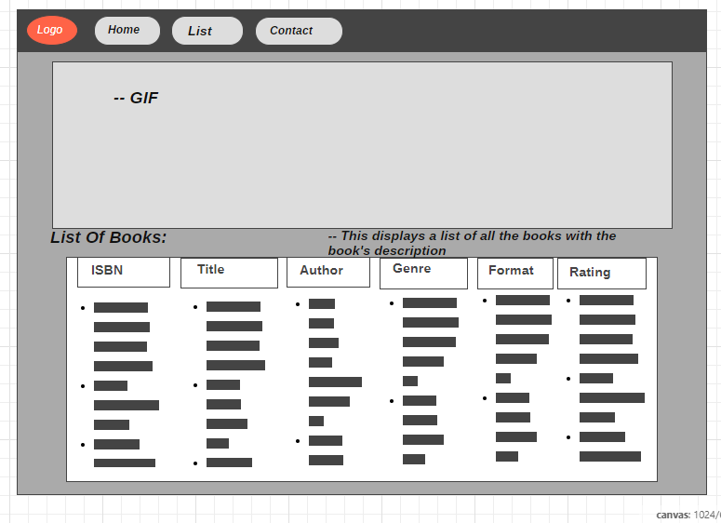

1. Wireframe for Contact Page:

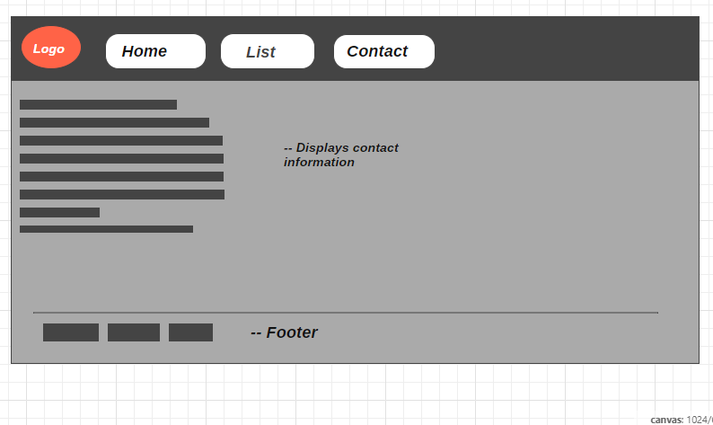

# Capture Section

